3265

Montgomery

Dr.

Gainesville,

Georgia

30504

770-534-7473

FAX

770-531-3055



Brittney Bennett, Program Director

# 2024-2025 Hall County Bright from the Start Dual Language Immersion Pre-K

***What is Georgia's Pre-K Program?*** Georgia's Pre-K Program is a lottery funded educational program for Georgia's four year olds to prepare children for Kindergarten. Children four years of age on September 1 of the current school year who are Georgia residents are eligible to attend Georgia's Pre-K Program during this school year. Georgia’s Pre-K Program is voluntary for families and for providers.

***What is Dual Language Immersion?*** Dual language immersion is a form of bilingual education in which students are taught literacy and content in two languages. Our students are provided instruction ninety percent of the day in Spanish and ten percent of the day in English.

**Locations:**

Chicopee Woods Elementary School: https://forms.gle/ADYn77U1VYp3gYjF6

Lyman Hall Elementary School: https://forms.gle/oTfmWjSh1ByU7ktg7

McEver Arts Academy: https://forms.gle/VQjLgdLRqwnSWYMV6

Sardis Elementary School: https://forms.gle/6fXizXqjAFJoqVKs7

Sugar Hill Elementary School: https://forms.gle/kg5cnvZQ3g2DsY63A

Sandra Dunagan Deal Elementary School: https://forms.gle/WQnEALYybi8qvTrn7

World Language Academy: https://forms.gle/qYsD7GNZszBAX1Ah8

**Pre-K Application/Waiting List Form is available electronically. Please click the link beside each site you are interested in attending.**

**The Pre-K Lottery will take place on March 5th at 10:00 am.**

(We will continue accepting Pre-K Waiting List applications after the lottery, and will place the students on the site waiting list throughout the year.)

**Pre-K Lottery Priority Acceptance List:**

Pre-K Site Hall County School District Employees (employees that work on site where applying)

Siblings (attending site where applying)

Hall County School District Employees (any Hall County School District site)

School Attendance Zone (does not apply to WLA-they do not have a school attendance zone)

Hall County Residents

Students who live outside of Hall County, but in the state of Georgia.

***We will hold two lotteries-Spanish and English to create a balance for our Dual-Immersion Pre-Ks.***

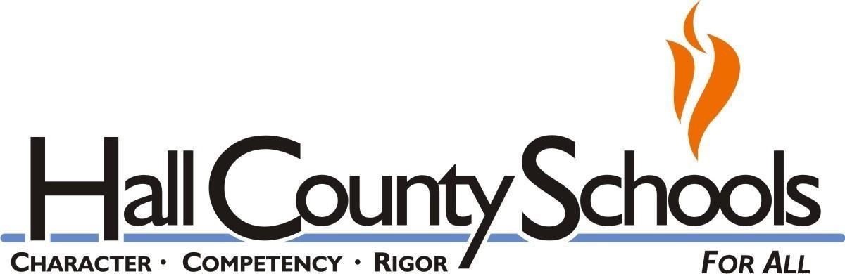

*Accredited by the Southern Association of Colleges and Schools*