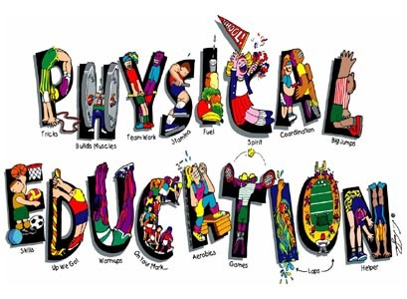  
  
  
  
**PHYSICAL EDUCATION ACTIVITIES**

**INSIDE SUGGESTIONS #1 :::**

1. Stretch your neck, arms, and legs along with your back and sides with slow smooth movements just like we do at the beginning of class.
2. Then do 10 Jumping Jacks, 10 Push Ups, 10 Lunges, 10 Sit Ups.
3. Repeat #2 if you still have energy and are up for it.
4. Cool down by standing still and taking long deep breathes, IN then OUT.  Repeat 3 times.

**INSIDE SUGGESTIONS #2 :::**

1. Play a Just Dance or Zumba Game (on your Wii XboX etc) for at least 30 minutes.  If you do not have that equipment, with your parents’ permission/help look them up on YouTube and follow the dances from there. Search: **Just Dance Kids**
2. OR with your parents’ permission/help, go to GoNoodle and sign up for a FREE account. Lots of good kid friendly movement videos to choose from.
3. OR with your parents’ permission/help look up various Kid Exercises on the internet and do them for 30 minutes.  If you find good ones, write them down so you can share with us at our next PE Class.

**OUTISDE SUGGESTIONS:::**

If you are able to: Run around the house a few times, jump rope, jumping jacks, ride your bicycle, play soccer, shoot basketball, etc. Get outside and get some movement.

**Remember to move and exercise as much as possible each day.**   
**30 Minutes a Day is GOOD   
BUT   
60 Minutes a Day is GREAT!!!**

Please feel free to contact me if you have any questions: [tony.villarini@hallco.org](mailto:tony.villarini@hallco.org)

Describe which activity you did: _________________________________________________________  
  
___________________________________________________________________________________

___________________________________________________________________________________

___________________________________________________________________________________  
  
___________________________________________________________________________________

___________________________________________________________________________________  
  
___________________________________________________________________________________

___________________________________________________________________________________  
  
  
Parent Signature______________________________________________________________________