SCHOOL FROM HOME
Hola ninos y ninas:

Bienvenidos a nuestra pagina School from Home “CLASE DE ARTE”….
Vas a encontrar tus tareas en la pagina de Google Classroom, sabes como llegar alli? Encontraras las indicaciones a continuacion. Tan pronto tengas la tarea tomale una foto y subela a classroom, o mandame una foto a mi correo francy.rodriguez@hallco.org
Ahhh! Y cuando tengas tiempo si quieres puedes disfrutar de la siguiente pagina gratis para colorear.
FREE COLORING PAGE
No olvides que el ultimo dia para entregar tu tarea es el proximo viernes.
Espero verte pronto en nuestra escuela.

Preguntas? Enviame un email
No te preocupes por ser perfecto porque no existe tal cosa! Solo enfocate en la diversion!

Gracias,

Mrs. Rodriguez
Art – Teacher
World Language Academy

HOW TO GO TO GOOGLE CLASSROOM FROM LAUNCHPOINT?

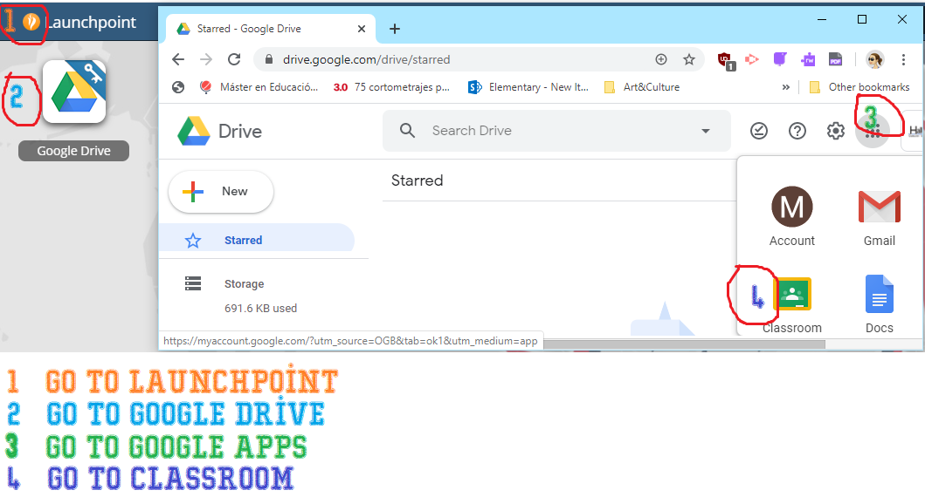

SCHOOL FROM HOME

Hello boys and girls:

Welcome to our School from Home ART CLASS page….
You will find your homework on the Google Classroom page; do you know how to get there? You will find the indications below. As soon as you have the task take a photo and upload it to the classroom or send me a photo to my email francy.rodriguez@hallco.org.

Ahhh! And when you have time if you want you can enjoy the following Free coloring page:

FREE COLORING PAGE
Don't forget that the last day to turn in your homework is this Friday.
Questions? Send me an email
Don't worry about being perfect because there is no such thing! Just focus on the fun, y'all!

Thank you,

Mrs. Rodriguez
Art – Teacher
World Language Academy

HOW TO GO TO GOOGLE CLASSROOM FROM LAUNCHPOINT?

